- Create a Jenkins Job to create a calculator. It should give you a dropdown to ask Addition, Subtraction, Multiplication or Division and mail the results.
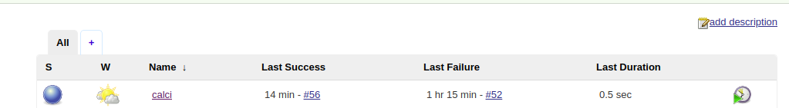
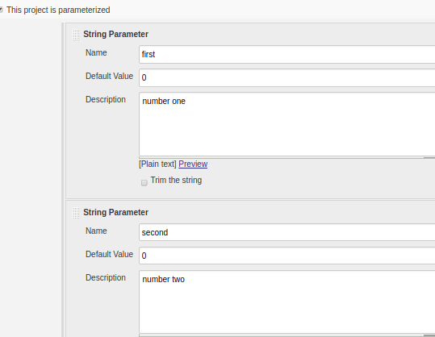
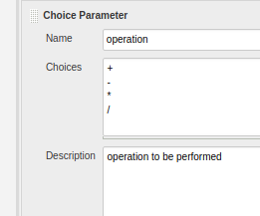
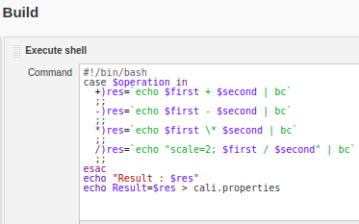
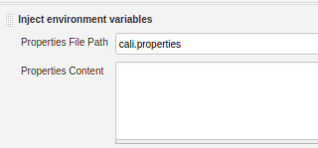
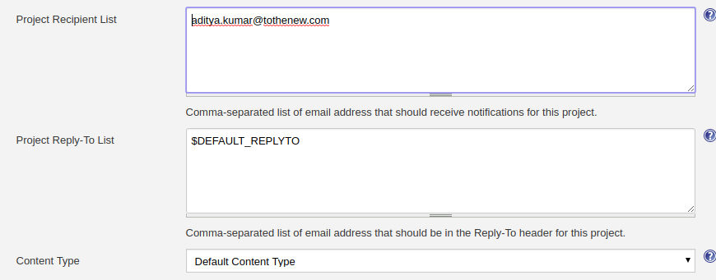
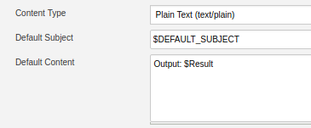
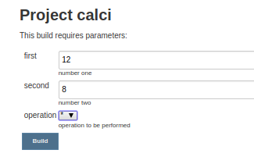
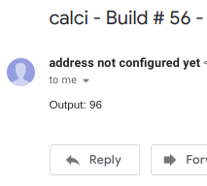

- Create Jenkins parameterized job which on selecting different the Env. will display different web pages by nginx.
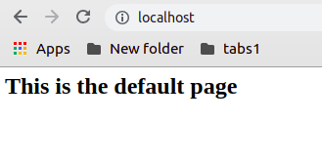
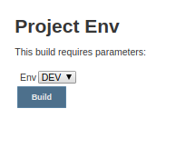
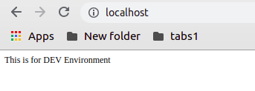
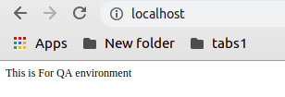
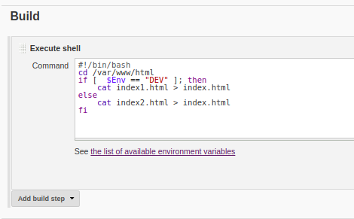

- Java deployment to server by Maven jenkin job.
  - Checkout SCM (https://github.com/bogo-devops/game-of-life.git)
  - Build with Maven plugin(Refer to above github URL)
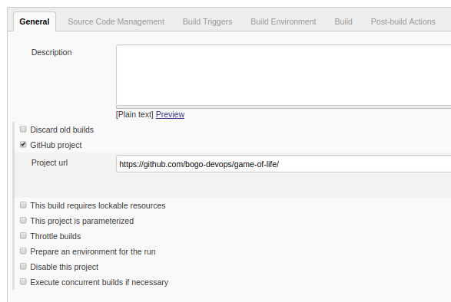
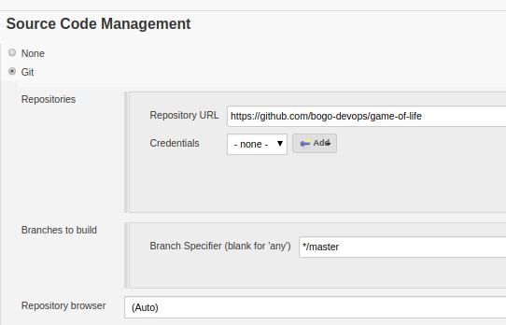
  - SCP war to
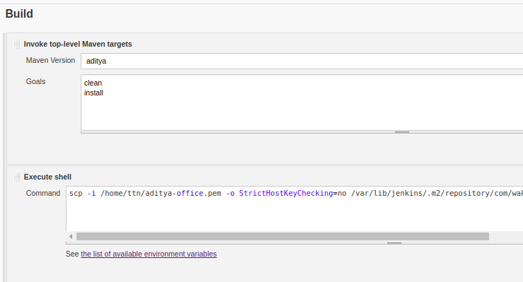
COMMAND:
scp -i /home/ttn/aditya-office.pem -o StrictHostKeyChecking=no /var/lib/jenkins/.m2/repository/com/wakaleo/gameoflife/gameoflife-web/1.0-SNAPSHOT/gameoflife-web-1.0-SNAPSHOT.war ubuntu@34.226.220.56:/var/lib/tomcat8/webapps
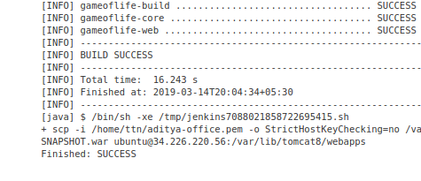
On remote host:
Server.xml :
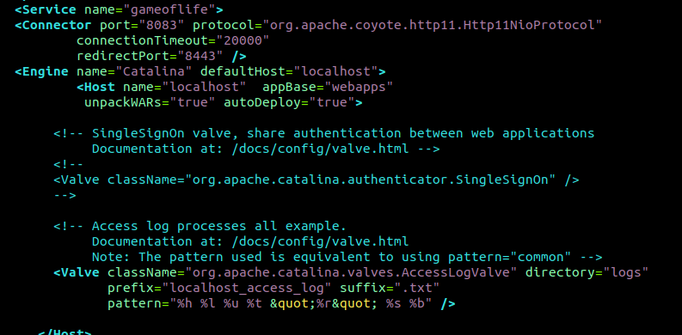
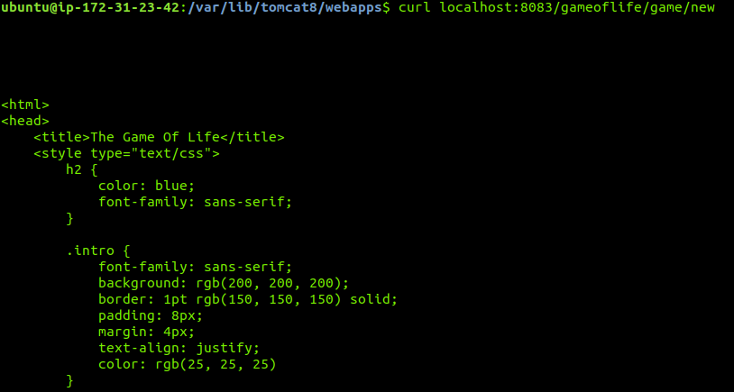
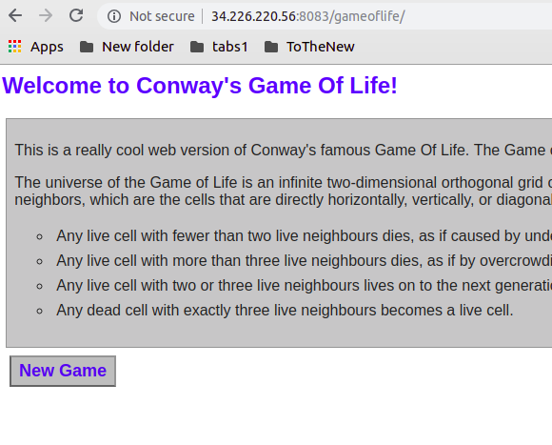

  - Jenkins User-based access:
  - Sample Jenkin Job Name: Test, Test123 and Test1234
- Jenkins User | - Acces to Jenkins Job Name
- user1 | - Test, Test123
- user2 | - Test123, test1234
